Chapter 16
Predictive Model of Personalized Recommender System of Users Purchase
Darshana Desai^{1*}
¹MCA Department, Indira College of Engineering and Management, Pune, India

ABSTRACT

Real-time personalization is adopted by e-commerce websites to leverage business opportunity with the offering recommendation which caters users’ implicit need, but little is known about its effect on users' privacy concerns and trust towards purchase behavior. This research develops a predictive model exploring the effect of personalization on users' trust and privacy concerns towards personalization and interrelation with the willingness to purchase with the e-commerce site. SEM is used to develop a model after EFA and CFA results. The result shows the model fit which of personalization and role of personalized information relevance towards the belief of trust and privacy concerns in e-commerce websites. Our findings suggest that: personalized recommendation is positively related with users’ satisfaction and privacy concerns. Result shows that users trust is not related with the privacy concerns, users experience less trust with high privacy concerns. Users with higher satisfaction with ecommerce websites are likely to develop more trust, although users purchase intention is not affected by satisfaction but it positively affects purchase intention if privacy concerns of the users are addressed in personalized recommendation.

Keyword: Predictive Model, Personalized Recommendation, Privacy Concerns, Trust, Satisfaction, Purchase Intentions, Collaborative Filtering
16.1 Introduction
Personalized Recommendation is used as an effective instrument to moderate the cognitive load of users on cybernetic markets on e-commerce websites with suggesting information about product, or services. Users' personal information, purchase behaviors, preferences, geo-location search and website trail are monitored and stored with latest information about the users to serve them better, by e-commerce sites. Real-time personalized recommendations are presented by understanding implicit tastes, surfing of websites, behavioral intents like time spent on the page, no. of the visit to pages, frequency of item viewed, search and purchase history with now and current data analytics. Continuous monitoring of the user's activities in order to create personalized recommendations and suggest highly relevant content, users’ detailed information is fetched on a real-time basis upon constant monitoring of users' activities which have raised privacy concerns and trust issues in e-commerce websites. Identification of users' personality traits and Also all these activities fuel data breaching which may lead to high privacy concerns, reduction in trust amongst users, and affect their purchase decisions. The personalization process needs more data with monitoring users' activities with the right context to generate highly relevant personalized recommendations. Users experience more privacy concerns with tracking of their activities and interaction. Different privacy policy is introduced to regulate the business process, data acquisition and its usage for commercial or other purpose including Do-Not-Track initiative and limiting data collection by providing users control for data collection which have reduced privacy concerns in users (Ghahtarani 2020, Mayer and Narayanan 2011, Wang and Kobsa 2007).
The research will provide a roadmap for business to use personalization features while considering privacy concerns and trust issues with personalized contents. The paper is ordered as below: Section 2 defines prior work in the context of personalized recommendation, trust, privacy concerns, satisfaction, and its effect on purchase behavior. Section 3 represents proposed hypotheses and last section 4 explains research methodology adopted to address the research question and analysis using Exploratory Factor Analysis and Confirmatory Factor Analysis. The section also shows results of model validity and SEM Model Subsequently, section 5 presents the result analysis, with hypothesis testing results and Discussion. Finally, section 6 represents findings and future scope of research.
16.2 Related Work

Personalized Recommendation produced in e-commerce websites on a real-time basis, is a continuous process addressing users' requirements with highly relevant information (Desai 2021, Desai 2019). The user's needs are identified implicitly by analyzing search history, website clicks, purchase history, demographics, likings and explicitly producing customization options and choices of filters(Desai 2015; Taylor et al. 2015; Liang et al. 2007; Chellappa and Sin 2005). Research suggests that recommendation services reduce users' cognitive load producing ease of use, perceived usefulness, and enjoy the shopping experience, subsequently leading to positive behavior of purchase and revisit to the e-commerce websites (Desai 2016, Liang et al. 2012, Mahrous 2012). Users experience higher satisfaction, more trust with greater interaction with an e-commerce website, show positive behavioral intention and purchase (Dabholkar et al. 2012, Desai 2019). On the contrary, users experience higher privacy concerns and lower satisfaction with the recommendation associated with higher financial risks (Stevenson 2015, Barth 2017). Research also suggests that recommendations of sensitive products generate higher privacy concerns in the user and are likely to experience lower trust in the e-commerce websites affecting negatively in behavioral intentions like revisit and purchase.

Personalized recommendation systems adopt different approaches and techniques to learn about users' preferences through analyzing users’ behavioral data like collaborative filtering, user profiling, content-based and hybrid model-based recommendation (Zhang et al. 2019, Desai 2015). Research has found significant performance improvement in business and customer experience with the personalized recommendation in e-commerce websites like Amazon.com use collaborative filtering technique to generate product recommendation by analyzing like-minded people purchase behavior and suggesting related items which are bought frequently together (Koustan and Riedl 2012, Pu et al. 2011)

Frequent interaction with the e-commerce websites and increased use of recommendation services produce increased satisfaction, higher trust, and greater purchase intentions. However trust in the recommendation is strongly associated with the users desire to avail personalization services (Dabholkar et al. 2012) and higher relevance of personalized recommendation to users implicit need and accuracy of recommendation induce more satisfaction in users instigating positive behavioral intentions like revisiting to the website and purchase(Desai 2019, Desai 2016, Stevenson 2015, Liang et al. 2007)

16.3 Gap Analysis
Earlier research clearly states that highly personalized recommendation and user behavioral tracking have raised more concerns towards privacy and security of the users’ information. Recently users’ privacy concerns have increased to prominently develop trust before purchasing on e-commerce websites. Personalization strategies have been used extensively over a decade to lower cognitive load on the user and influence for high returns in business but little is focused on customer data privacy and their concerns on information disclosure. Though users’ satisfaction and cognitive behavior with personalized information is researched towards its effect on purchase intentions (Desai 2019), studies have shown a deficit in addressing the issue of impact of personalized recommendations on users purchase intention through intrinsic feeling of trust and privacy concerns. In this view to address the research gap, our research explores personalized recommendations used in e-commerce website Amazon.com on users' purchase behavior through privacy concerns and trust in the website.
16.4 Research Hypotheses
Research in personalization has shown a significant relation between information personalization and users' intention to revisit the website. Our research framework proposes interrelation of personalized recommendation, privacy concerns, trust, satisfaction, and behavioral intention of user-like purchase in e-commerce websites.
Personalized Recommendation, Privacy Concerns

Users personal information is used in order to produce personalized content (Gupta et al 2015; Shin et al 2010) and apprehend users implicit requirement by observing website usage and trailing(Desai 2015) purchase conduct, preferences has the prospective for an incursion of privacy. Users having higher privacy concerns Website users may have concerns about privacy of users with website personalization in case users are unaware about the motive after personalized information which eventually diminishes trust in ecommerce sites. Users’ involvement develops privacy concerns whenever recommendation process utilize their personal information without consent, prior knowledge generating adverse emotion with the personalized ecommerce website.

H1: User exhibits more privacy concerns with higher personalized recommendation.
Personalized Recommendation and Satisfaction
Users experience greater satisfaction with when produced information with high relevance fulfilling their implicit needs leading to perceived ease of use, and usefulness of the recommendation. Explicit personalization or customization choices offered to users produces feeling of control and participation in personalized recommendation process. This generates higher satisfaction in the user and interaction with the personalized ecommerce website becomes more joyful. (Desai 2019, Desai 2016). So this research work hypothesizes:

H2: User experience satisfaction is positively associated with personalized recommendations.

Privacy Concern with Trust

Personalized websites lessens users’ cognitive exertions taken to hunt information and users experience developed satisfaction by highly relevant personalized information (Desai 2019, Desai 2022) eventually developing trust towards websites. Users with higher privacy concerns need more control over personalization to progress trust in the ecommerce websites ( Desai 2021). Users desire to maintain privacy of the information build higher trust when fulfilled with implicit requirements. Personalized recommendation generates cognitive benefits to users with compromise in information privacy. Personalization process requires users’ demographic, personal and behavioral information including their likings and needs based on search history. This information disclosure produce privacy concerns with the associated privacy risk in regards to information or content personalization (Stevenson et. al. 2015). So Research hypothesizes:

H3: Users shows higher trust when privacy concerns are addressed properly.

Privacy Concerns and purchase intention

User’s privacy concerns is intrinsic desire to control information disclosure and its use. Users show higher privacy concerns when their information privacy is breached while interaction with the website or online transaction. Users concerns about privacy and trust is preserved when their anonymity is preserved and have choices to control through customization options to tailor users’ environment. Prior research have established that users control over information sharing is the key factor in development of concerns about privacy and website environment (Sheehan Hoy 1999). Users identify lower risk about privacy of their information when provided with higher control over website and customization options along with disclosure to privacy policies and users are likely to purchase more when their privacy concerns are addressed properly with the policies and security of the information. (Mohamed et. al. 2012, Desai 2020). So researcher postulates:

H4: Users' purchase intention is associated with privacy concerns.

Satisfaction, Trust and purchase intention

Trust is inherent feeling of the user and preparedness to be susceptible to the actions with prospect and addressed expectations (Yerizal 2021, Dwyer 2007). Users having control with information distribution, display, accessibility of personal information & security of the personal details, are more likely to develop higher satisfaction and confidence in e-commerce web portals. Personalized information having high relevance like recommendations, location based services, targeted commercials produce intrinsic feeling of trust and satisfaction to motivate purchase with the website. So, we propose:

H5: Users experience more trust with higher satisfaction.

H6: Users' purchase intention is highly associated with users' Trust.

H7: Users purchase intention is highly associated with users Satisfaction

16.5 Methodology of Research
Data Collection and Sampling

Our research provides predictive model of users purchase intention on Amazon.in e-commerce website who are using this site for more than two years. The data was collected based on real purchase of the users on the amazon.in site. The constructs were recognized from the preceding studies are personalized recommendation, privacy concerns, satisfaction, trust, and purchase intention, were identified using question having five-point Likert scale.
Table 1: Sample demographics
Measure | Item | Frequency
Gender | Male | 328
 | Female | 172
Age (years) | 18–25 | 392
 | 26–35 | 68
 | 36–50 | 38
 | >50 | 2
Education | Undergraduate | 183
 | Graduate degree | 120
 | Post Graduate | 195
 | Doctorate | 2
Occupation | Student | 363
 | Service | 106
 | Self-employment | 12
 | Homemakers/Retired | 19
Experienced | Directly | 428
Personalization | Indirectly | 72

Data Analysis & Measurement Model

Pilot study of the research with the 50 responses gave confirmation about the construct reliability and validity of the questions in survey. The respondents were all over India who have purchased online on Amazon.in e-commerce websites and have experienced personalization in the form of the personalized recommendation of product, service, or information directly or indirectly. The Data was collected through stratified sampling technique. 441 useable responses were extracted out of 500 received responses through data preprocessing. Data cleaning was done after the removal of noisy, improper, unfinished, and inconsistent data. In order to retrieve final responses researcher considered data after removal of responses below standard deviation .30 which was further used for data analysis. Extracted factors with exploratory factor analysis were further confirmed with CFA Confirmatory Factor Analysis. SPSS Amos 21.0 was used for structural Equation Modeling (SEM) technique, to identify best fit of the suggested.

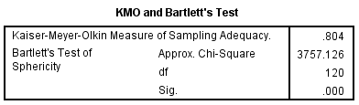
Figure 1: KMO Bartlett Test Result

KMO and Bartlett’s test result value 0.804 which is above 0.7 shows sample size adequacy of data collection, Exploratory Factor Analysis techniques discovered 5 factors named personalized recommendation, trust, privacy concerns, satisfaction, and purchase intentions through extraction method Maximum Likelihood. Figure 2 below shows 5 factors with 61.312% of the cumulative load.
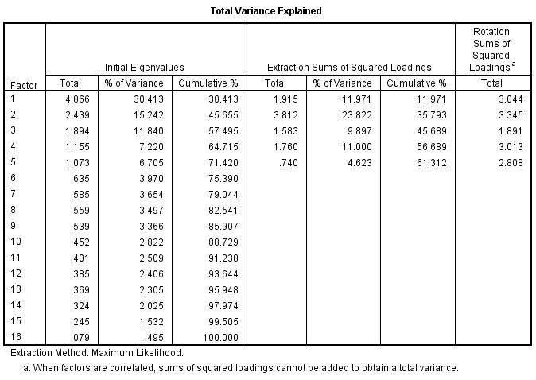
Figure 2: Total Variance

The Cronbach’s Alpha coefficient standards of construct items were observed between the range of 0.70 and 0.90 displaying higher constructs internal consistency and consistency of questionnaire items or constructs. Construct items Factor loading values were identified above 0.5 in Figure 3, showing satisfactory factor loading with higher construct validity and reliability.
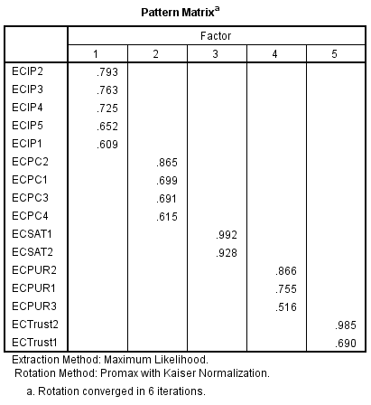
Figure 3: Pattern Matrix

Figure 4: below shows the factor correlation matrix shows the interrelation of the factors identified after EFA.
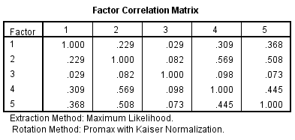
Figure 4: Factor Correlation Matrix

Confirmatory Factor Analysis and Validity Test

Conﬁrmatory Factor Analysis technique was used to check the proposed model fit with SPSS AMOS 21.0. Best Fit of the model is shown when the fit indices of the mode is within the accepted range and suggested values, the values shown in the below table displays acceptable fit as the model fit indexes surpasses the suggested value.

Composite Reliability displays constructs internal consistency of the item which is above 0.7 representing good reliability and measurement items constancy of every construct item. Each CR scored above 0.8, which is higher the value by recommended Fornell and Larcker (1981), signifying good reliability and constancy for the measurement items of each construct.

Bagozzi and Yi (1988) suggested standards for the Convergent Validity of proposed measurement model as mentioned: (1) construct factor loadings should be higher value than 0.5 (Hair et al., 1998); (2) Composite Reliability (CR) should be above 0.7; and (3) Average Variance Extracted (AVE) score of each construct should exceed 0.5 (Fornell&Larcker, 1981). Table 2 result shows factor loading of construct values of Composite Reliability is above 0.7 and AVE score of the constructs between 0.5 to 0.96 shows good convergent validity and strong inter item correlations with the constructs.

Table 2: CR, AVE & Discriminant Validity
 | CR | AVE | PI | PR | PC | SAT | Trust
PI | 0.788 | 0.555 | 0.745
PR | 0.836 | 0.507 | 0.311 | 0.712
PC | 0.821 | 0.534 | 0.612 | 0.235 | 0.731
SAT | 0.984 | 0.969 | 0.096 | 0.027 | 0.064 | 0.984
Trust | 0.834 | 0.715 | 0.505 | 0.385 | 0.540 | 0.068 | 0.846

CR- Composite Reliability AVE-Average Variance Extracted
PR-Personalized Recommendation PC-Privacy Concerns
SAT-Satisfaction PI –Purchase Intentions

Fornell and Larcker 1981 suggested constructs’ AVE score should exceed correlation coefficients of the construct for the discriminant validity of the model (). The correlation coefficient value shown in Table 2 in the proposed research model and where diagonal elements represent square roots of the constructs’ Average Variance Extracted value. The AVE score for the constructs is higher than the square root of the correlation coefficient values for any two constructs. Research shows decent discriminant validity of the constructs identified in proposed model measurement as all the constructs are distinct from each other. Construct reliability, discriminant validity, and convergent validity of the research shows good fit values of the measurement model.

Structural Equation Modeling

The result of Structural Equation Modeling shows good model fit satisfying all the criteria of fit indices of the model having values v2/df = 1.772, GFI = 0.961 AGFI = 0.94, NFI = 0.95, CFI = 0.98, RMSEA = 0.039 . Values shown for the fit indices of model in structural equation modeling directs good fit for the model.
Figure 5 shows variance explained (R²) and standardized path coefficient illustrate that all the proposed hypotheses are proven except users’ privacy concerns and trust showing users are not aware of privacy concerns. It also shows that users purchase is not dependent of trust on the personalized websites. R² variance explained values of purchase intentions and Trust are 0.32 and 0.46 which is higher than 0.3 indicates that proposed research model is good and accurate.

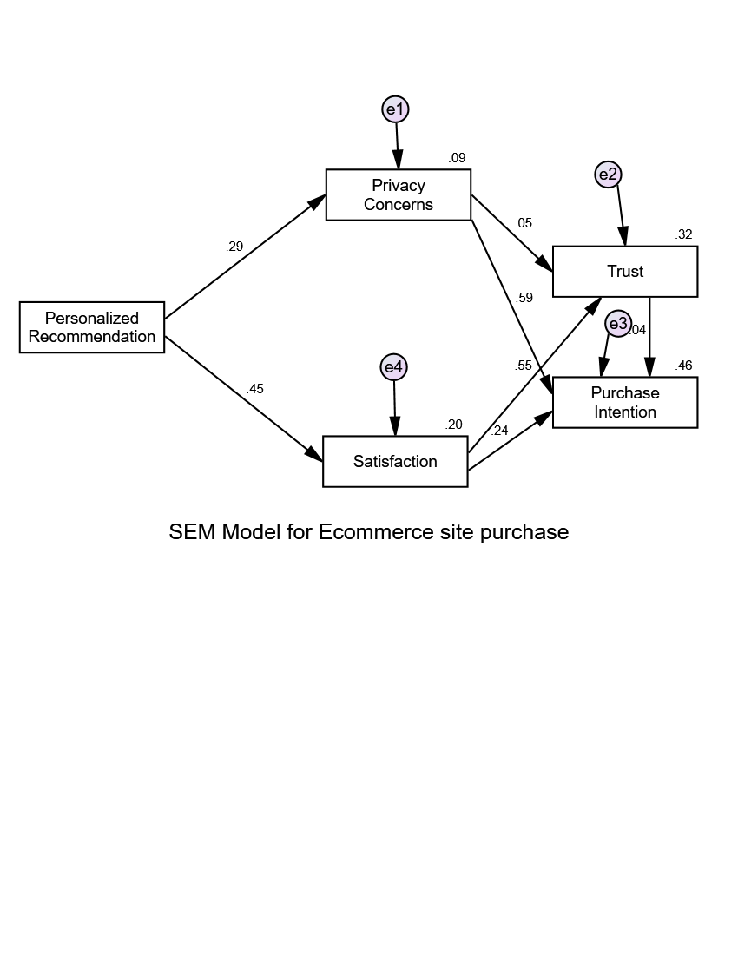

Figure 5: Structural Equation Modeling Result

16.6 Result & Discussion:

Hypothesis testing result shown in table 3 represent that users demonstrates concerns about privacy with the increase in personalized recommendations and feel satisfied with the highly relevant recommendations which address their needs. Research results show that users’ trust is not affected by privacy concerns but it is highly related with the satisfaction with the personalized recommendations. Users' purchase behavior with ecommerce websites depends on privacy concerns and trust with the site. Users are likely to purchase if users’ privacy concerns are addressed properly while offering personalized recommendations. The result also shows the willingness of the user to purchase is not affected by Satisfaction.

Table 3: Hypotheses Testing Result
Hypotheses Testing | Estimate | S.E | C.R. | P- Value
H1: User exhibits more privacy concerns with higher personalized recommendation | .296 | .043 | 6.835 | ***
H2: User experience satisfaction is positively associated with personalized recommendations | .493 | .044 | 11.246 | ***
H3: Users shows higher trust when privacy concerns are addressed properly. | .076 | .054 | 1.406 | .160
H4: Users purchase intention is highly associated with users Satisfaction | .740 | .050 | 14.826 | ***
H5: Users experience more trust with higher satisfaction. | .246 | .040 | 6.129 | ***
H6: Users' purchase intention is highly associated with users' Trust | .646 | .036 | 17.809 | ***
H7: Users' purchase intention is associated with privacy concerns | .027 | .030 | .890 | .373

*** indicates p value < 0.001
Our study collected data from Amazon users were personalized recommendations are generated based on collaborative filtering mechanism. As mentioned in hypothesis 1 User exhibits more privacy concerns with higher personalized recommendation is proven with the result. Users also experience satisfaction is positively associated with personalized recommendations which is supported with the result of p-value in hypothesis 2. When users concerns about privacy are addressed through customization and users control over website personalization produce trust and satisfaction with the ecommerce website which is in line with the proved hypothesis 3 & 5. Users purchase intentions with the website is positively associated with the trust and satisfaction supporting proposed hypothesis, also purchase intentions are affected by users privacy concerns.
.
16.7 Conclusions & Future Scope of Research:
Users’ privacy concerns and satisfaction in ecommerce websites personalized recommendation plays a significant role in developing trust and positive behavioral intention to purchase with the e-commerce website. Personalized recommendations on ecommerce websites lead to higher satisfaction in case of users' implicit needs are satisfied with the high relevance with expectation. On the other hand it may lead to high privacy concerns if recommendations are not addressed properly. Users' purchase intention is affected by privacy concerns and users' satisfaction with the personalized recommendations lead to trust development towards the site resulting in positive purchase intentions. Result shows that personalized recommendation is positively associated with users’ satisfaction and privacy concerns. Users experience lesser trust towards websites with high privacy concerns but the result shows that users' purchase intentions are not affected by satisfaction but are positively affected by trust and privacy concerns.
The proposed research shows qualitative study on users’ purchase intention in Amazon.in on an e-commerce website. Research adopted survey-based method through questionnaire collection for the study with further extension to explore users purchase intent in a lab with controlled environment. Research can be further enhanced with the personalized recommendations attributes and focus on deep insight of optimization of recommendations with high relevance based on the real-time analytics of the users’ interactions and search. Real-time predictive analytics model can be further proposed to address users’ dynamic need in future in considering both types of data using big data analytics techniques and real time personalization.

References:

- Bagozzi, R.P., Yi, Y. (1988). On the evaluation of structural equation models. JAMS 16, 74–94 https://doi.org/10.1007/BF02723327
- Barth, S., & de Jong, M. D. T. (2017). The privacy paradox – Investigating discrepancies between expressed privacy concerns and actual online behavior – A systematic literature review. In Telematics and Informatics (Vol. 34, Issue 7, pp. 1038–1058). Elsevier Ltd. https://doi.org/10.1016/j.tele.2017.04.013
- Chellappa, R.K., Sin, R.G. (2005). Personalization versus Privacy: An Empirical Examination of the Online Consumer’s Dilemma. Information Technology Manage 6, 181–202 https://doi.org/10.1007/s10799-005-5879-y
- Dabholkar, P. a., & Sheng, X. (2012). Consumer participation in using online recommendation agents: effects on satisfaction, trust, and purchase intentions. The Service Industries Journal, 32(9), 1433–1449. https://doi.org/10.1080/02642069.2011.624596
- Desai D. (2021). Role of Privacy Concern and Control to Build Trust in Personalized Social Networking Sites. In: Sheth A., Sinhal A., Shrivastava A., Pandey A.K. (eds) Intelligent Systems. Algorithms for Intelligent Systems. Springer, Singapore. https://doi.org/10.1007/978-981-16-2248-9_10 (Scopus Indexed)
- Desai D. (2019). "Personalization Aspects Affecting Users’ Intention to Revisit Social Networking Site" Published in International Journal of Trend in Scientific Research and Development (ijtsrd), ISSN: 2456-6470, Volume-4 | Issue-1, December, pp.612-621 URL: www.ijtsrd.com/papers/ijtsrd29631.pdf
- Desai D. (2018). An Empirical Study of Website Personalization Effect on Users Intention to Revisit E-commerce Website through Cognitive and Hedonic Experience. In: Balas V., Sharma N., Chakrabarti A. (eds) Data Management, Analytics, and Innovation. Advances in Intelligent Systems and Computing, vol 839. Springer. https://doi.org/10.1007/978-981-13-1274-8_1
- Desai D. Kumar S. (2015). “Web Personalization: A perspective of design and implementation strategies in Websites“ Khoj: Journal of Management Research & Practices,109-119 ISSN No: 0976-8262.
- Desai D.(2016). “A study of personalization effect on users’ satisfaction with ecommerce Websites” Sankalpa- Journal of Management & Research" Volume 6, Issue 2, 51-62 ISSN No. 2231-1904.
- Desai, D. (2022). Hyper-Personalization: An AI-Enabled Personalization for Customer-Centric Marketing. In Adoption and Implementation of AI in Customer Relationship Management (pp. 40-53). IGI Global.
- Dwyer, C., Hiltz, S. R. and Passerini, K. (2007). ‘Trust and privacy concerns within social networking sites: A comparison of Facebook and MySpace’, Americas Conference on Information Systems, Proceedings of the Thirteenth Americas Conference on Information Systems, Keystone, 9–12 August, Colorado, USA, p. 339. https://aisel.aisnet.org/amcis2007/339
- Fornell, C., &Larcker, D. (1981). Evaluating Structural Equation Models with Unobservable Variables and Measurement Error. Journal of Marketing Research, 18(1), 39-50. doi:10.2307/3151312

- Ghahtarani, A., Sheikhmohammady, M., &Rostami, M. (2020). The impact of social capital and social interaction on customers’ purchase intention, considering knowledge sharing in social commerce context. Journal of Innovation and Knowledge, 5(3), 191–199. https://doi.org/10.1016/j.jik.2019.08.004
- Gupta, A., &Dhami, A. (2015). Measuring the impact of security, trust, and privacy in information sharing: A study on social networking sites. Journal of Direct, Data and Digital Marketing Practice, 17(1), 43–53. https://doi.org/10.1057/dddmp.2015.32
- Konstan, J. A., Riedl, J., Konstan, J. A., &Riedl, J. (2012). Recommender systems: from algorithms to user experience. 22, 101–123. https://doi.org/10.1007/s11257-011-9112-x
- Liang, T.-P., Chen, H.-Y., Du, T., Turban, E., & Li, Y. (2012). Effect of Personalization on the Perceived Usefulness of Online Customer Services: a Dual-Core Theory. Journal of Electronic Commerce Research, 13(4), 275–288. http://www.ecrc.nsysu.edu.tw/liang/paper/2/79 Effect of Personalization on the Perceived (JECR, 2012).pdf
- Mahrous, A. A. (2011). Antecedents of privacy concerns and their online actual purchase consequences: a cross-country comparison. In Int. J. Electronic Marketing and Retailing Vol. 4, Issue 4
- Mayer, J.R., Narayanan, A.(2011) Do not track iab/w3c/ietf position paper. Tech. rep., W3C
- Mohamed, N. and Ahmad, I. H. (2012). Information privacy concerns, antecedents and privacy measure use in social networking sites: Evidence from Malaysia, Computers in Human Behavior, Vol. 28, No. 6, pp. 2366–2375 DOI: https://doi.org/10.1016/j.chb.2012.07.008
- Pu P, Chen L, and Hu R (2011). A User-Centric Evaluation Framework for Recommender Systems. Proceedings of the Fifth ACM Conference on Recommender Systems (ACM), 157-164.
- Sheehan, K.B., Hoy, M.G. (1999). “Flaming, Complaining, Abstaining: How Online Users Respond to Privacy Concerns”, Journal of Advertising, (28), 3: 37-51.
- Shin, D.(2010). The effects of trust, security, and privacy in social networking: A security-based approach to understand the pattern of adoption, Interacting with Computers,22(5),.428-438 https://doi.org/10.1016/j.intcom.2010.05.001
- Stevenson, Darren, and Pasek(2015). Privacy Concern, Trust, and Desire for Content Personalization The 43rd Research Conference on Communication, Information and Internet Policy. http://dx.doi.org/10.2139/ssrn.2587541
- Sutanto, J., Palme, E., Tan, C., &Phang, C. (2013). Addressing the Personalization-Privacy Paradox: An Empirical Assessment from a Field Experiment on Smartphone Users. MIS Quarterly, 37(4), 1141-1164. Retrieved March 5, 2021, from http://www.jstor.org/stable/43825785
- Taylor, D.G., Davis, D., &Jillapalli, R. (2009). Privacy concern and online personalization: The moderating effects of information control and compensation. Electronic Commerce Research, 9, 203-223. DOI:10.1007/s10660-009-9036-2
- Wang, Y., Kobsa, A.(2007). Respecting users’ individual privacy constraints in web personalization. In: Conati,C., McCoy, K., Paliouras, G. (eds.) UM07, 11th international conference on user modeling, Berlin– Heidelberg–New York, pp. 157–166. Springer-Verlag, Corfu
- Yerizal, Y., &Abror, A. (2019). The Influence of E-Wom and Image Destination on Revisit Decision Moderated by Trust: A Literature Review. https://doi.org/10.2991/piceeba2-18.2019.58
- Zhang S, Yao L, Sun A, and Tay Y. (2019). Deep Learning Based Recommender System: A Survey and New Perspectives. ACM Computing Surveys (CSUR) 52(1): 1-38.

